Name: Muhammad Ahmad  
reg # 2021331

CS354 Deep learning

By Dr Shahab Ansari

Assignment # 4

Report Title: Deep Learning Model for Image Classification

INTRODUCTION:

In today's world, there are lots of pictures everywhere, and we need ways to sort them automatically. That's why having good systems to tell apart different kinds of images is important. This report is about making and testing a special computer program that can tell if a picture shows a cat or a dog. We want to see how well this program, which uses something called convolutional neural networks (CNNs), can do this job.

Model Architecture:

* The model is composed of multiple layers arranged sequentially.
* Initial layers focus on detecting simple shapes and patterns, such as edges and corners, within the images.
* Following layers build upon these initial features to identify more intricate patterns like fur texture or whiskers.
* Through this hierarchical process, the model gradually learns to distinguish between images of cats and dogs.
* The final layers are responsible for making the ultimate decision on whether an image depicts a cat or a dog.
* The model's accuracy in classifying images relies on its ability to extract and interpret features at different levels of complexity.

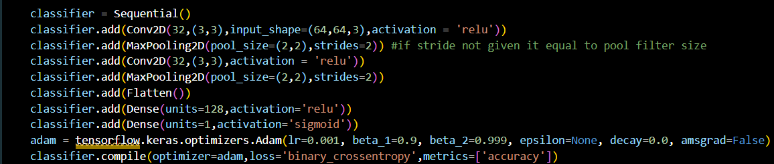

* Two convolutional layers (Conv2D) with ReLU activation function.
* Two max-pooling layers (MaxPooling2D) to reduce spatial dimensions.
* A flattening layer (Flatten) to convert the 2D feature maps into a vector.
* Two fully connected layers (Dense) with ReLU and sigmoid activation functions, respectively.

DATA AUGMENTATION:

Using some Data Augmentation techniques for more data and Better results.

* Shearing of images
* Random zoom
* Horizontal flips

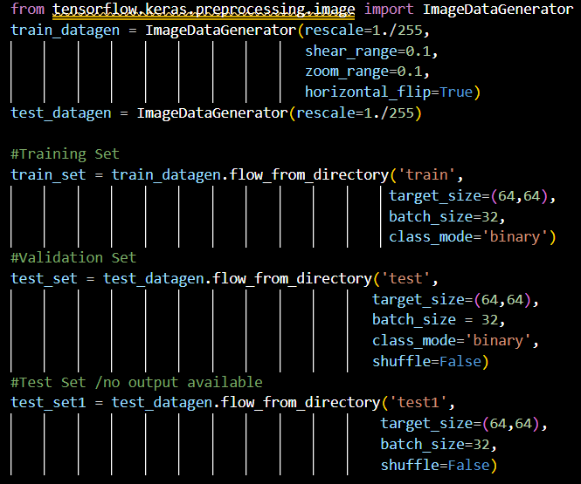

EVALUATION:

We analyze the performance of the trained model on the validation set using a confusion matrix. This matrix provides a detailed breakdown of the model's predictions compared to the actual labels, allowing us to assess its accuracy and identify any misclassifications.

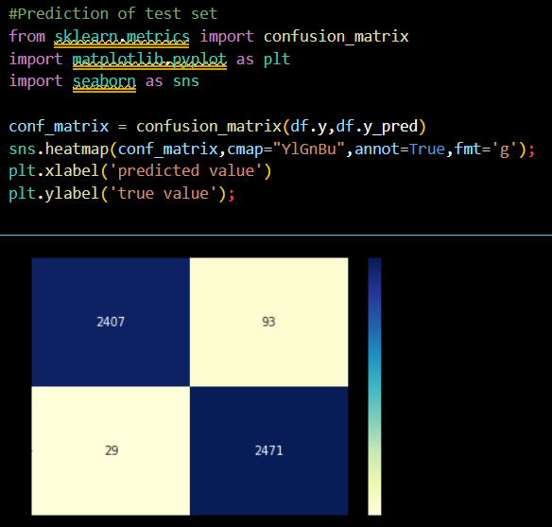

PREDICTION EXAMPLES:

We showcase the model's capabilities by making predictions on a variety of images. Initially, we demonstrate the model's performance on a single image depicting a cat, providing insights into its ability to correctly classify individual instances. Subsequently, we extend the analysis to multiple images, illustrating how the model performs across a diverse range of inputs. This comprehensive approach allows us to evaluate the model's robustness and generalization ability in classifying images of cats and dogs.

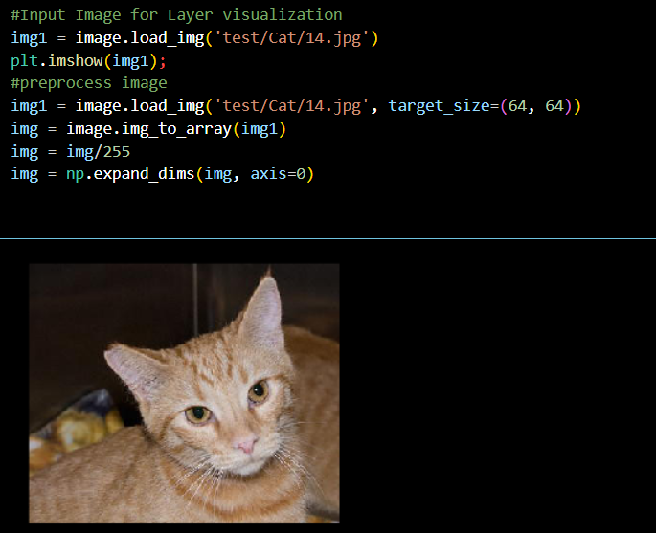

Top of Form

Model Behavior on Entire Dataset:

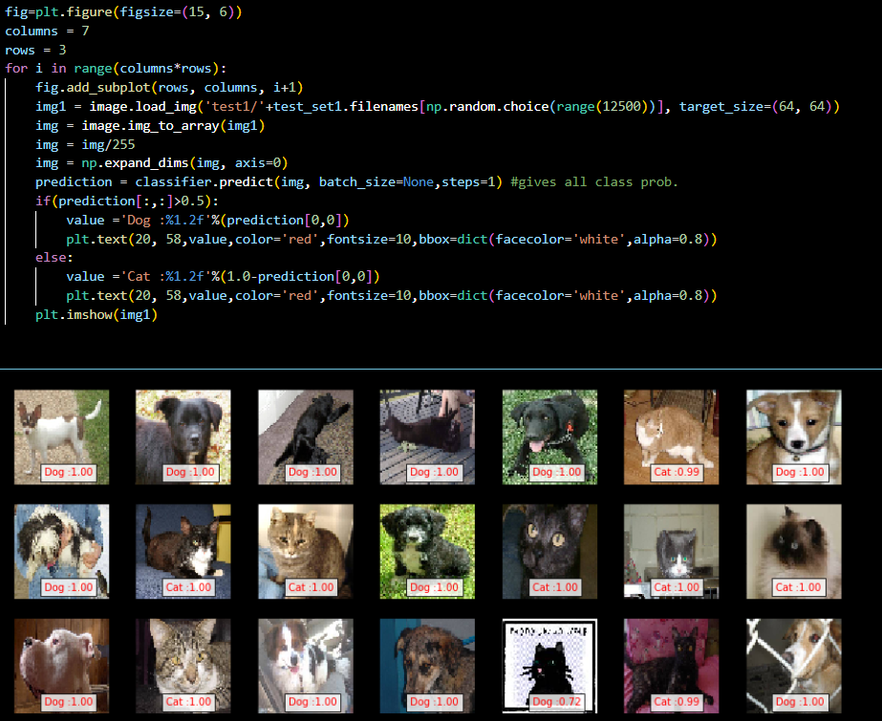

CONCLUSION:

In summary, the achieved accuracies highlight the model's strong performance in accurately classifying images of cats and dogs, both during training and when evaluated on unseen validation data. These results underscore the model's efficacy and reliability, laying a solid foundation for its potential deployment in real-world applications with high confidence and precision.

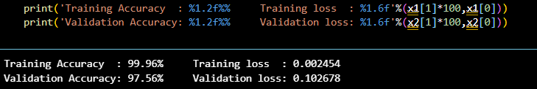

The model has demonstrated exceptional training accuracy, reaching an impressive 99.96%, coupled with a remarkably low training loss of 0.002454. This high training accuracy indicates that the model has successfully learned the intricate patterns and features present in the training data, enabling it to make accurate predictions on familiar images.

Moreover, the model exhibits a commendable validation accuracy of 97.56%, accompanied by a validation loss of 0.102678. This validation accuracy, although slightly lower than the training accuracy, signifies the model's ability to generalize well to unseen data, thereby showcasing its robustness and effectiveness in classifying images of cats and dogs beyond the training set.